**Team Name: BROids**

**Team Members:**

* Rajan Vyas - rajan.n.vyas@gmail.com
* Brijesh Masrani - brijesh.masrani@gmail.com
* Mahendra Liya - liyamahendra4@gmail.com
* Dawar Dedmari - dawardedmari@gmail.com

**Problem Statement - 1**

**Make property walkthroughs more interesting**

PK wears his intergalactic viewer to scan the planets around him from the comfort of his spaceship. His co-pilot next to him is viewing the same planets as PK on his tablet. However, co-ordination between them is a constant struggle as although they are looking at the same land, PK looks in one direction of the land while his co-pilot looks in another. Is there a way we can synchronize what they view across these devices while also enabling them to highlight attributes they want each other to notice.

**Our Approach**

**Introduction:**

Seven years back, when eComs like flipkart started their operations in India, every buyer had a question in their mind –

"How can I buy something without seeing/checking/feeling the item or product first hand"

No one asks that question anymore. Ordering and paying for things online has become integral to our online experience.

When we look at the problem statement above, we can see a similar question pop up into the heads of the future potential buyers or renters of property in the Indian real estate market.

"How can I think about buying/renting a land/property without seeing/checking it first"

An our approach is to answer it by not only taking the whole process of a site visit online but also to make it more engaging for the user by using VR.

But before that lets list the issues with an actual physical site visit.

**Issues with physical site visits:**

Time Consuming – Visiting new projects/sites usually means long commutes and that to lesser developed areas usually far off from the city.

Cost Prohibitive: A consumer cannot visit as many sites as he/she would like to simply because of the logistics and cost involved in planning and executing each trip.

As such, user choice is severely restricted in such an existing system.

An our approach is to answer it by not only taking the whole process of a site visit online but also to make it more engaging for the user by using VR.

**Our Solution:**

Our team is not looking for gimmicky features. Our aim is to build a VR engine which will eventually result in a seamless and immersive shopping experience for the end user. This would lead to more user engagement and faster buying/renting decisions leading to quicker turn around times on the platform.

We would like to take a narrative approach to explain our solution below. But before that, let us just list our assumptions:

**Assumptions:**

* There exists a technology platform like a fully functional app e.g. housing.com, which has listings of assets/properties.
* The platform gives the user the options to search/filter the available properties according to his/her needs.
* The user reaches a page displaying a list of properties, which meet his/her criteria.

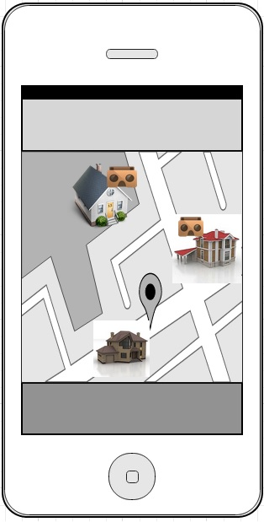

From this point onwards, our user is presented with three key services based o n our VR platform:

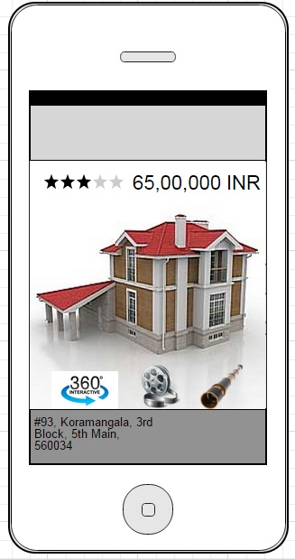

1. **360 ° - Three sixty degree viewer:**

A user can launch the 360 degree view by clicking on the smart icon below any listing. This launches an photosphere image based VR experience for a quick look around the property.

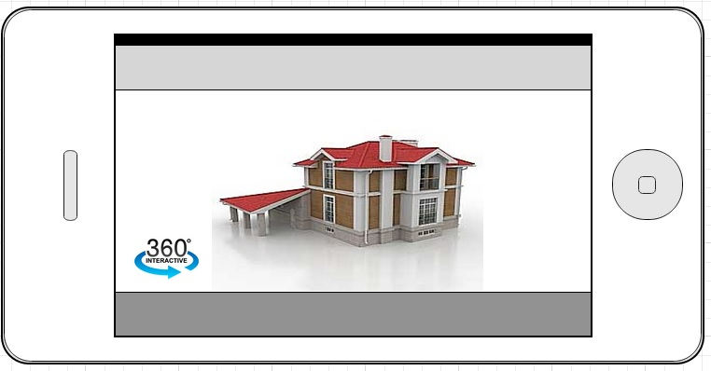

1. **Bioscope – The video walk through:**

This feature gives the user a “site expert” guided tour of the property, explaining and highlighting various features that may be focused for a particular property. The tour leverages the VR engine to give the user a “walk through” experience.

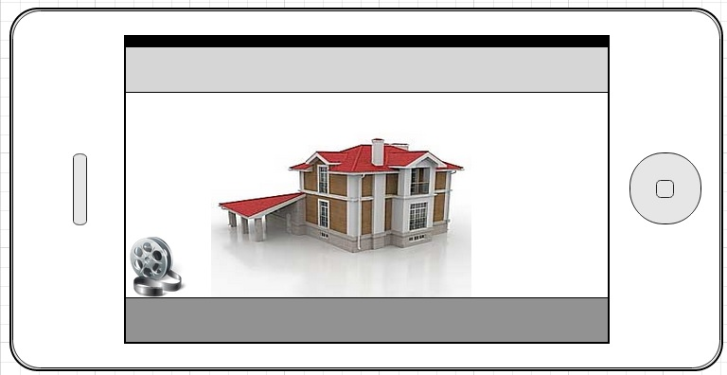

1. **Telescope – Seeing is believing:**

This is our most ambitious feature because it addresses the biggest customer issue – trust deficit in things related to real estate in India. Telescope is a live streaming service where a “site expert” actually visits the property and while he/she is there, streams a live AV stream to the potential customers. This service will be available in two modes:

**3.a Request a Telescope:** This feature is available to end customers. If they see a property they are interested in, they can simply click the “telescope” icon to request a stream. If a stream is available, a session is immediately initiated with the customer by the site expert who gets notified that a potential customer is interested in his/her property.

However, in most cases, a stream may not be available immediately. In such cases, the platform logs in this request and will alert the user when the stream is available for that particular property in the future. The user may then choose to accept or reject this stream. User may also share this stream with family and friends to enable a joint session. After all, things are more fun

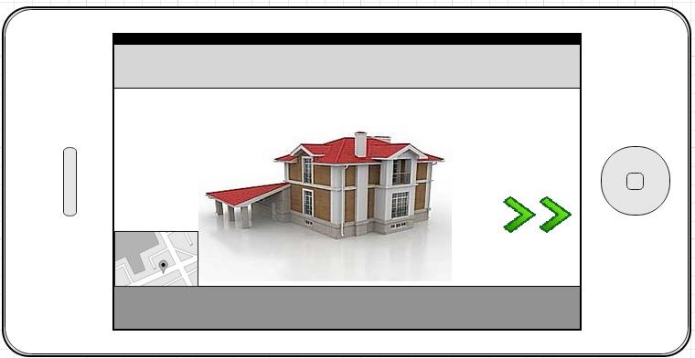

**3.b Broadcast a telescope:** This service is targeted at the realtors who are assigned the role of partners. When a realtor initiates a new project, they can approach the Platform and set up events to act at marketing and customer reach out programs using telescope broadcasts. In such scenarios, potential customers are identified using their past search history on the platform and targeted with the new campaign. A special event is organized at the new project site and users are invited to access the multiple streaming event at any given point of the day.

All these services above do not mean that the customer will not do a physical site visit, at least not in the near future especially in a market like India where legal hassles and property records are distinctive possibilities.

However, out hope is that these services will lead to such benefits as:

* Remove the gap between a potential customer and the property, giving the customer a “feel” of the asset without an actual visit.
* Reduce the burden on the customer and thereby trust deficit in such property deals
* Make the customer decide faster and make his shopping experience more engaging thereby leading to happier customers.

Today, the customer may short list ten properties and check them out using our VR services above. He/she may like two of them enough to go and actually visit them.

But one day, in the not so distant future, we hope that our VR platform becomes powerful enough to achieve such customer confidence that they can take buy/sell decisions solely on the basis of it.

**Potential Services in the future:**

**SiteCam:** This services is meant to be a bridge between realtors and buyers where a 360 degree cam with motion motors can be installed at a new construction site. The customers can use a simple app interface to control the camera and get a view on the progress and current state of a project before making a decision on it.

**Technology Stack:**

* Android SDK
* Cardboard SDK
* Wowza Streaming Engine

**We would love to “be a partner” in making this vision a reality!!**